Ex. No. : 04 Date: 25-02-2026
Register No.: 231701023 Name: S.V.Jashwanth

Gesture-Based Interaction App
Aim
To develop an Android application using Kotlin that detects and responds to user gestures such as single tap, double tap, long press, and swipe in all directions.

Procedure:
- Open Android Studio and create a new project using the Empty Views Activity template.
- Select Kotlin as the programming language.
- Design the user interface in activity_main.xml using a ConstraintLayout and TextView.
- Create a second activity (MainActivity2) for performing gesture detection.
- Implement gesture detection using:
- GestureDetector for:
  - Single Tap
  - Double Tap
  - Long Press
- Manual swipe detection using MotionEvent for:
  - Right Swipe
  - Left Swipe
  - Up Swipe
  - Down Swipe
- Attach a setOnTouchListener to the layout to capture touch events.
- Use setText() with string resources from strings.xml to update messages dynamically.
- Add the second activity in AndroidManifest.xml.
- Run the application on an emulator or physical device.
- Perform gestures on the screen and observe the corresponding output.
AndroidManifest.xml

<?xml version="1.0" encoding="utf-8"?>
<manifest xmlns:android="http://schemas.android.com/apk/res/android"
xmlns:tools="http://schemas.android.com/tools">
<application
android:allowBackup="true"
android:dataExtractionRules="@xml/data_extraction_rules"
android:fullBackupContent="@xml/backup_rules"
android:icon="@mipmap/ic_launcher"
android:label="@string/app_name"
android:roundIcon="@mipmap/ic_launcher_round"
android:supportsRtl="true"
android:theme="@style/Theme.Text">
<activity android:name=".MainActivity2" />
<activity
android:name=".MainActivity"
android:exported="true">
<intent-filter>
<action android:name="android.intent.action.MAIN" />
<category android:name="android.intent.category.LAUNCHER" />
</intent-filter>
</activity>
<meta-data
android:name="preloaded_fonts"
android:resource="@array/preloaded_fonts" />
</application>
</manifest>

Activity_main.xml

<?xml version="1.0" encoding="utf-8"?>
<androidx.constraintlayout.widget.ConstraintLayout
xmlns:android="http://schemas.android.com/apk/res/android"
xmlns:app="http://schemas.android.com/apk/res-auto"
android:id="@+id/main"
android:layout_width="match_parent"
android:layout_height="match_parent"
android:background="#E3F2FD">
<TextView
android:id="@+id/tvMain"
android:layout_width="wrap_content"
android:layout_height="wrap_content"
android:fontFamily="@font/crete_round"
android:gravity="center"
android:text="@string/main_message"
android:textSize="22sp"
android:textStyle="bold"
app:layout_constraintBottom_toBottomOf="parent"
app:layout_constraintEnd_toEndOf="parent"
app:layout_constraintStart_toStartOf="parent"
app:layout_constraintTop_toTopOf="parent" />
</androidx.constraintlayout.widget.ConstraintLayout>
Activity_main2.xml
<?xml version="1.0" encoding="utf-8"?>
<androidx.constraintlayout.widget.ConstraintLayout
xmlns:android="http://schemas.android.com/apk/res/android"
xmlns:app="http://schemas.android.com/apk/res-auto"
android:id="@+id/main"
android:layout_width="match_parent"
android:layout_height="match_parent"
android:background="#C8E6C9">
<TextView
android:id="@+id/tv2"
android:layout_width="wrap_content"
android:layout_height="wrap_content"
android:fontFamily="@font/crete_round"
android:gravity="center"
android:text="@string/gesture_default"
android:textAlignment="center"
android:textSize="24sp"
android:textStyle="bold"
app:layout_constraintBottom_toBottomOf="parent"
app:layout_constraintEnd_toEndOf="parent"
app:layout_constraintStart_toStartOf="parent"
app:layout_constraintTop_toTopOf="parent" />
</androidx.constraintlayout.widget.ConstraintLayout>

MainActivity.kt

package com.example.text
import android.content.Intent
import android.os.Bundle
import android.view.GestureDetector
import android.view.MotionEvent
import androidx.appcompat.app.AppCompatActivity
class MainActivity : AppCompatActivity() {
private lateinit var detector: GestureDetector
override fun onCreate(savedInstanceState: Bundle?) {
super.onCreate(savedInstanceState)
setContentView(R.layout.activity_main)
detector = GestureDetector(this,
object : GestureDetector.SimpleOnGestureListener() {
override fun onDown(e: MotionEvent): Boolean {
return true
}
override fun onDoubleTap(e: MotionEvent): Boolean {
startActivity(Intent(this@MainActivity, MainActivity2::class.java))
return true
}
})
}
override fun onTouchEvent(event: MotionEvent): Boolean {
return detector.onTouchEvent(event)
}
}

MainActivity2.kt

package com.example.text
import android.os.Bundle
import android.view.GestureDetector
import android.view.MotionEvent
import android.view.View
import android.widget.TextView
import androidx.appcompat.app.AppCompatActivity
import kotlin.math.abs
class MainActivity2 : AppCompatActivity() {
private lateinit var tv: TextView
private lateinit var detector: GestureDetector
private var startX = 0f
private var startY = 0f
override fun onCreate(savedInstanceState: Bundle?) {
super.onCreate(savedInstanceState)
setContentView(R.layout.activity_main2)
tv = findViewById(R.id.tv2)
detector = GestureDetector(
this,
object : GestureDetector.SimpleOnGestureListener() {
override fun onDown(e: MotionEvent): Boolean = true
override fun onSingleTapConfirmed(e: MotionEvent): Boolean {
tv.setText(R.string.single_tap)
return true
}
override fun onDoubleTap(e: MotionEvent): Boolean {
tv.setText(R.string.double_tap)
return true
}
override fun onLongPress(e: MotionEvent) {
tv.setText(R.string.long_press)
}
})
val layout = findViewById<View>(R.id.main)
layout.setOnTouchListener { view, event ->
detector.onTouchEvent(event)
when (event.action) {
MotionEvent.ACTION_DOWN -> {
startX = event.x
startY = event.y
}
MotionEvent.ACTION_UP -> {
val diffX = event.x - startX
val diffY = event.y - startY
val minDistance = 120
if (kotlin.math.abs(diffX) > kotlin.math.abs(diffY)) {
if (kotlin.math.abs(diffX) > minDistance) {
if (diffX > 0) {
tv.setText(R.string.swipe_right)
} else {
tv.setText(R.string.swipe_left)
}
}
} else {
if (kotlin.math.abs(diffY) > minDistance) {
if (diffY > 0) {
tv.setText(R.string.swipe_down)
} else {
tv.setText(R.string.swipe_up)
}
}
}
view.performClick()
}
}
true
}
}
}

Output
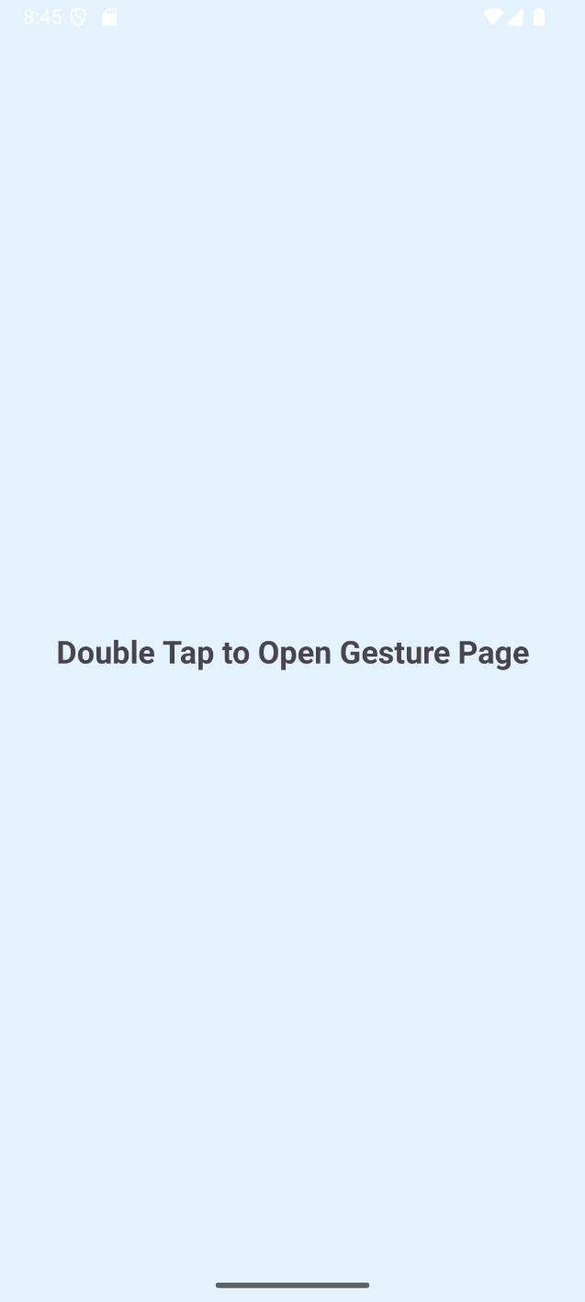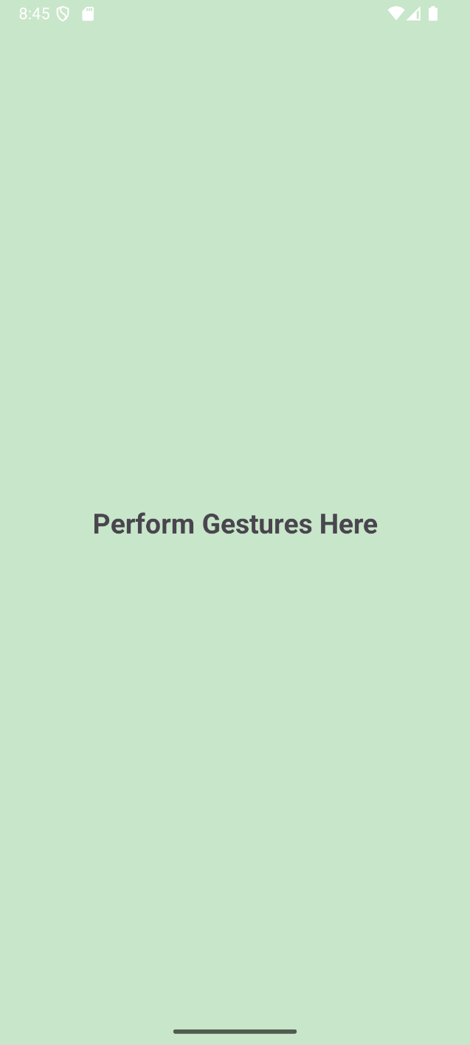

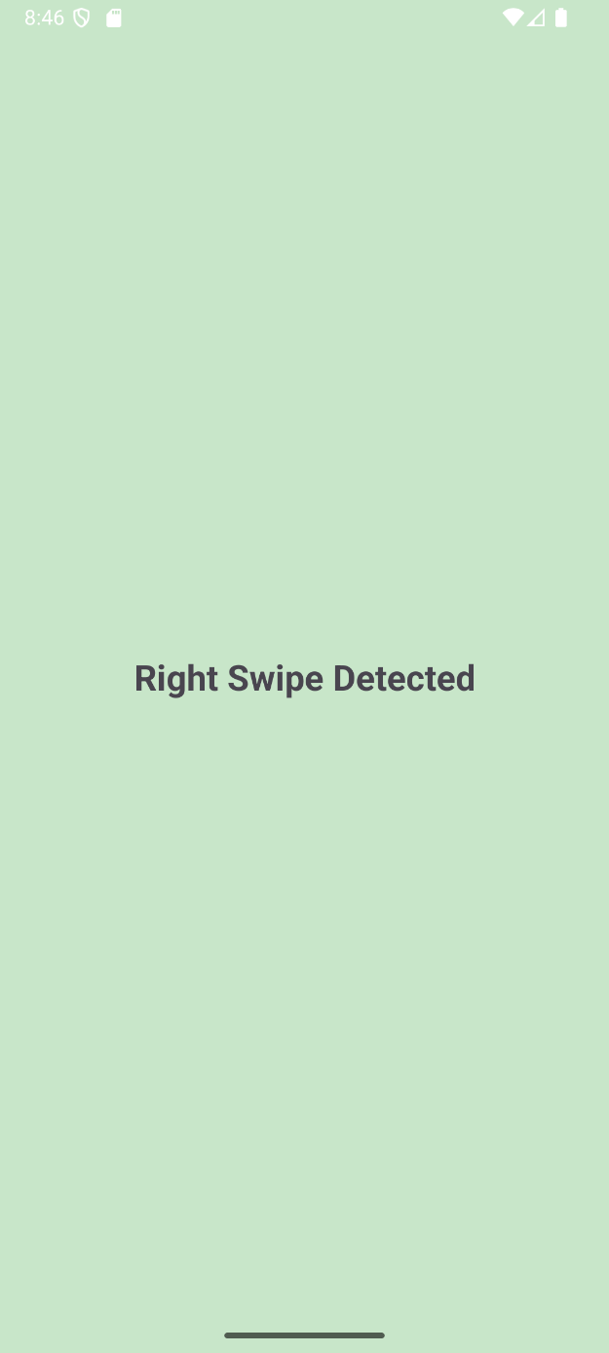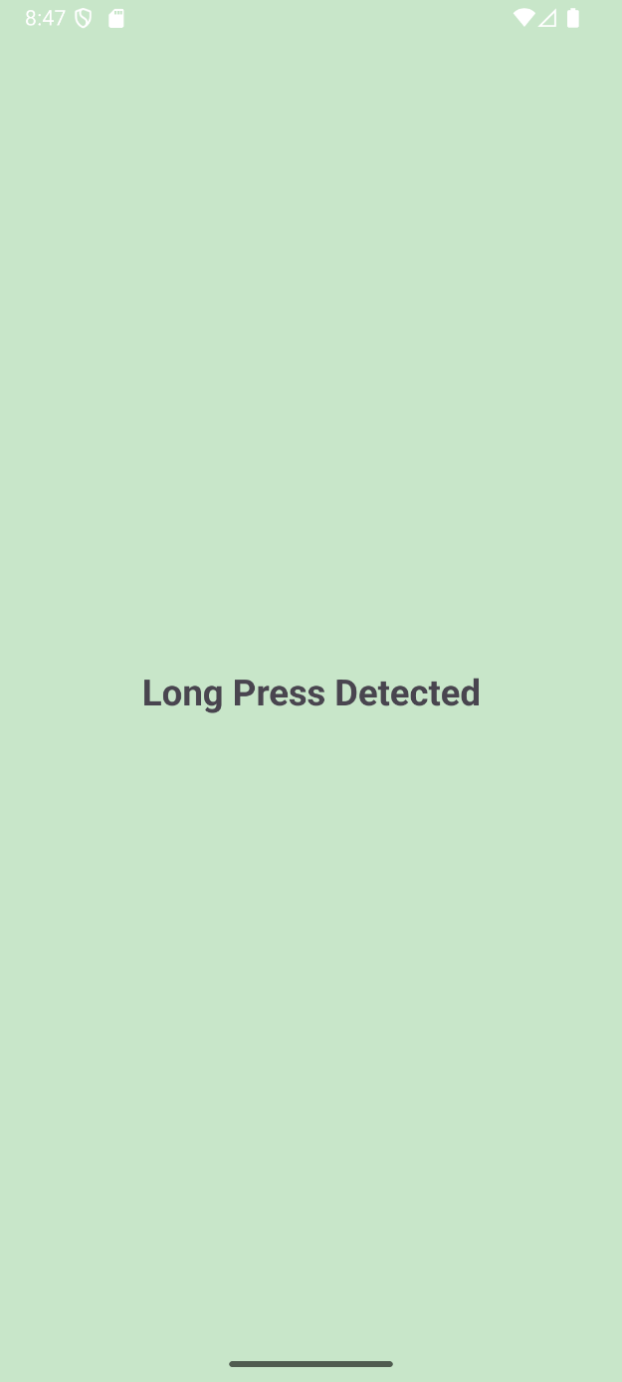

Result:
The application was successfully implemented and tested, and it correctly detects and displays messages for all performed gestures with smooth navigation between activities.

